Data Structure and Algorithm
Laboratory Activity No. 5

Implementation of Arrays

Submitted by: | Instructor:
Balana, Jerkielle Roen O. | Engr. Maria Rizette H. Sayo

August 16, 2025

Objectives
Introduction
Array, in general, refers to an orderly arrangement of data elements. Array is a type of data structure that stores data elements in adjacent locations. Array is considered as linear data structure that stores elements of same data types. Hence, it is also called as a linear homogenous data structure.

This laboratory activity aims to implement the principles and techniques in:
- Writing algorithms using Array data structure
- Writing a python program that can implement Array data structure

Methods
- Write a Python program to create an array of 10 integers and display the array items. Access individual elements through indexes and compute for the sum.
- Write a Python program to append a new item to the end of the array. Original array: numbers = [1, 2, 3, 4, 5, 6, 7, 8, 9, 10]
- Write a Python program to insert a new item before the second element in an existing array. Original array: numbers = [1, 2, 3, 4, 5, 6, 7, 8, 9, 10]
- Write a Python program to reverse the order of the items in the array. Original array: numbers = [5, 4, 3, 2, 1]
Write a Python program to get the length of the array. Original array: numbers = [5, 4, 3, 2, 1]

Results
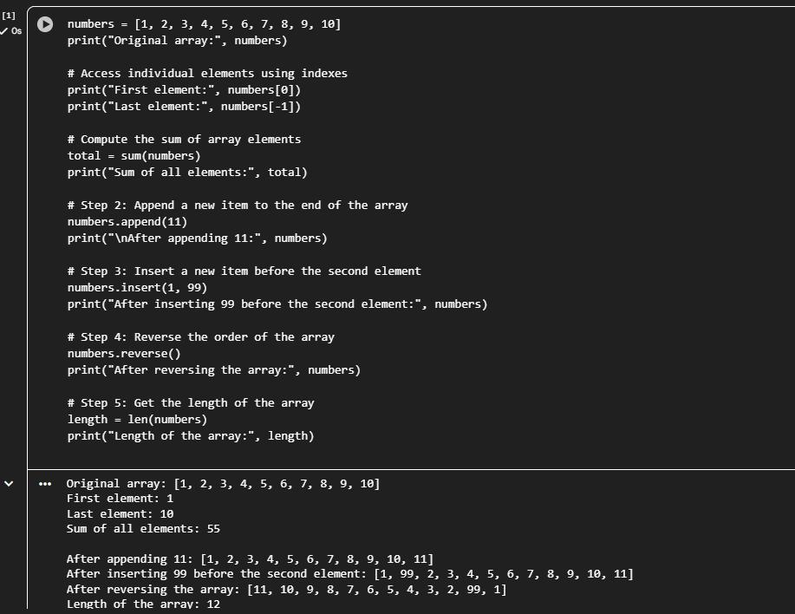

The program successfully demonstrated the different operations that can be performed on arrays in Python. The output showed the original array, followed by changes after each operation such as appending, inserting, reversing, and determining the length. Each result verified that arrays can store and manipulate multiple elements efficiently using built-in methods. Overall, the results confirmed that array operations are essential for organizing data and supporting more complex algorithms in programming.

Conclusion
The conclusion expresses the summary of the whole laboratory report as perceived by the authors of the report.
This lab activity successfully demonstrated basic concepts and applications of the array as a linear data structure through various implementations of array operations in Python. We were able to appreciate how an array organizes and manipulates data efficiently by going through the creation of an array, access to elements, appending new data, inserting elements at desired positions, reversing the order, and determining the length. Each method has pointed out that indexing is an important aspect of dynamic data handling in algorithm design and program optimization. In essence, this activity has further solidified our understanding of how an array works as the backbone for more complex data structures and algorithms in computer engineering.

References
[1] Co Arthur O.. “University of Caloocan City Computer Engineering Department Honor Code,” UCC-CpE Departmental Policies, 2020.

